**CST–130 Introduction to Visual Basic**

**Chapter 3**

**Lab # 6**

**William Eason**

**3/6/2019**

**Chapter 3 Review Questions 11-20**

11. Which of the following declares a procedure-level String variable?

**(d.) Both b and c**

12. When entered in the txtName_Enter procedure, which of the following statement will select all of the text box’s existing text?

**(a.) txtName.SelectAll ( )**

13.If Option Strict is set to On, which of the following statements will assign the contents of the txtSales control to a Double variable named dblSales?

**(c.) Double.TryParse (txtSales.Text, dblSales)**

14. Which of the following declares a named constant having the Double data type?

**(a.) Const dblRATE As Double = 0.09**

15. If Option Strict is set to On, which of the following statements assign the sum of two Integer variables to the Text property of the lblTotal control

(a.) lblTotal.Text = (intN1 + intN2).ToString

16. Which of the following statements prevents data loss due to implicit type conversions?

**(d.) Option Strict On**

17.

18.

19.

20.

* 1. Screenshots for Grade Average Calculator

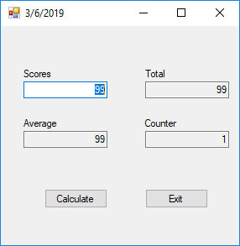 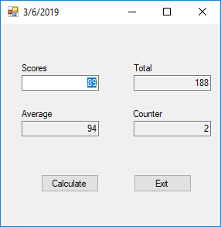

1.2) Program Results Verification

1.3) Source Code for Grade Average Calculator

' Copyright (c) 2019 Union County College. All Rights Reserved.

' CST-130-051 Visual Basic

'

' Name: Grade Average Calculator

' Purpose: Average scores and display counter for each entered score

' Programmed by: William Eason on 3/6/2019

Option Explicit On 'Must define a Variable

Option Infer Off 'Must Define a datatype for given variable

Option Strict On 'Follow strict datatype conversion rules

Public Class frmMain

Private dblTotal As Double

Private Sub btnCalc_Click(sender As Object, e As EventArgs) Handles btnCalc.Click

Static dblTotal As Double

Dim dblScore As Double

Static dblCounter As Double

Dim dblAverage As Double

Double.TryParse(txtScores.Text, dblScore)

'Change Title

Me.Text = Now.Date.ToShortDateString

'Sum The Scores

dblTotal = dblTotal + dblScore

'Find the number of scores

dblCounter = dblCounter + 1

'Show Total Score

txtTotal.Text = dblTotal.ToString("n0")

'Show Total count

txtCounter.Text = dblCounter.ToString("n0")

'Calculate Average

dblAverage = dblTotal / dblCounter

'Display Average

txtAverage.Text = dblAverage.ToString("n0")

'Focus back on scores text box

txtScores.Focus()

End Sub

Private Sub Form1_Load(sender As Object, e As EventArgs) Handles MyBase.Load

End Sub

Private Sub txtScores_TextChanged(sender As Object, e As EventArgs) Handles txtScores.TextChanged

txtCounter.Text = String.Empty

txtTotal.Text = String.Empty

txtAverage.Text = String.Empty

End Sub

Private Sub txtScores_Enter(sender As Object, e As EventArgs) Handles txtScores.Enter

txtScores.SelectAll()

End Sub

Private Sub btnExit_Click(sender As Object, e As EventArgs) Handles btnExit.Click

Me.Close()

End Sub

End Class

2.1) Commission Program Screenshots

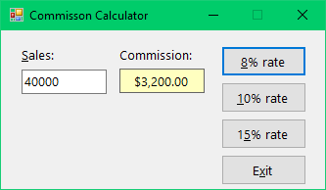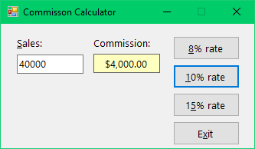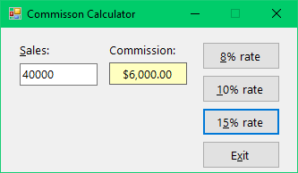

2.2) Program Results Verification

2.3) Commission Calculator Source Code

' Name: Commission Project

' Purpose: Displays a salesperson's commission.

' Programmer: William Eason on <current date>

Option Explicit On

Option Strict On

Option Infer Off

Public Class frmMain

Private Sub btnExit_Click(sender As Object, e As EventArgs) Handles btnExit.Click

Me.Close()

End Sub

Private Sub btnRate10_Click(sender As Object, e As EventArgs) Handles btnRate10.Click

' Calculates and displays a 10% commission.

' Declare two procedure-level variables that can

' be used only within the btnRate10_Click procedure.

Dim decSales As Decimal

Dim decComm10 As Decimal

' Convert the txtSales.Text property to Decimal. Store

' the result in the procedure-level decSales variable.

Decimal.TryParse(txtSales.Text, decSales)

' Multiply the value in the procedure-level decSales

' variable by the Decimal number 0.1D. Assign the

' result to the procedure-level decComm10 variable.

decComm10 = decSales * 0.1D

' Convert the value in the procedure-level decComm10

' variable to String. Assign the result to the

' lblCommission.Text property.

lblCommission.Text = decComm10.ToString("C2")

End Sub

Private Sub btnRate8_Click(sender As Object, e As EventArgs) Handles btnRate8.Click

' Calculates and displays an 8% commission.

' Declare two procedure-level variables that can

' be used only within the btnRate8_Click procedure.

Dim decSales As Decimal

Dim decComm8 As Decimal

' Convert the txtSales.Text property to Decimal. Store

' the result in the procedure-level decSales variable.

Decimal.TryParse(txtSales.Text, decSales)

' Multiply the value in the procedure-level decSales

' variable by the Decimal number 0.08D. Assign the

' result to the procedure-level decComm8 variable.

decComm8 = decSales * 0.08D

' Convert the value in the procedure-level decComm8

' variable to String. Assign the result to the

' lblCommission.Text property.

lblCommission.Text = decComm8.ToString("C2")

End Sub

Private Sub frmMain_Load(sender As Object, e As EventArgs) Handles MyBase.Load

End Sub

Private Sub btnRate15_Click(sender As Object, e As EventArgs) Handles btnRate15.Click

' Calculates and displays an 15% commission.

' Declare two procedure-level variables that can

' be used only within the btnRate15_Click procedure.

Dim decSales As Decimal

Dim decComm15 As Decimal

' Convert the txtSales.Text property to Decimal. Store

' the result in the procedure-level decSales variable.

Decimal.TryParse(txtSales.Text, decSales)

' Multiply the value in the procedure-level decSales

' variable by the Decimal number 0.15D. Assign the

' result to the procedure-level decComm15 variable.

decComm15 = decSales * 0.15D

' Convert the value in the procedure-level decComm15

' variable to String. Assign the result to the

' lblCommission.Text property.

lblCommission.Text = decComm15.ToString("C2")

End Sub

End Class

3.1) Updated Property Tax Screenshots

3.2) Program Results Verification

3.3) Updated Property Tax source code